March 11th, 2012
Hi
Today today the first anniversary of the devastating earthquake and tsunami that hit Japan.
Well, I have a flat to move into. Last Sunday, as I mentioned in the previous letter, I went to look at another flat and afterwards signed a preliminary contract. In many ways, this one is much better than the one I had seen two days prior. The earlier one, Flat G on the 53/F, was too high (only four floors from the top). It supposedly had a sea view but all one could see was a 'sea' of air pollution and not water. Also, a road was visible and so it was noisier. However, it was extremely clean and in perfect condition. But the lady who was there (I suspect she might have been the landlady) was very fussy about making even the slightest scratch of the paintwork and might have been a pain to deal with. The one I eventually took is Flat G on the 16/F in the next tower. It is in pretty good condition, no road view and overlooks the podium/swimming pool below from a height that does not give one vertigo. It is also more protected from the Sun which, of course, is very hot in the summer. Also, from the balcony, it has quite a good view of the park, though the 'benefit' having a good view often wears off, as I found with the marvellous view we had at CUHK. The rent is also a bit cheaper. Being on the 16/F, its height above the podium/swimming pool is about the same as Suite 1118 is above the road. The lease starts at the end of March, though my lease here at the hotel does not end until the end of May so there is two months of overlap and so in costs. This is not bad though as, to get a discount here, I took it out the lease for 12 months with a sliding scale, with more expensive monthly rents at the start and gradually decreasing so that April's rent is only about 2/3 of the average while May is 'free'. So, I will stay here until the end of May and gradually shift things over and get some furniture, probably from Ikea. Refer to the plans at the end of the letter for the location of the flat and its layout. It has a liveable floor area of about 440 square feet which is larger than the suite here. This in in contrast to the advertised 673 square feet which is because, in HK, developers take car parks, recreation areas, lift areas, etc. and share the areas of these common areas among the flats!! Very deceptive!! Adding up the years, staying here in Suite 1118 for almost 12 years is the second longest stay in any accommodation in my life. The longest stay, at 15 years, was in Flat 5B at CU. Even in NZ, I longest I ever stayed in one place was only about 10 years (the first 10 years of my life).
Last night, I went to a dinner for the 45th anniversary of the school I taught at when I first came to HK. Very good. Attending were about 18 teachers from the 7½ years I was at the school. As former teachers, we got the dinner for free! This is the first Chinese dinner I have been to for about two years. In this restaurant, instead of dishes being placed on the table for everyone to take food from, the waiters divided the food into separate portions for each person, which means you get food if you want it or not and cannot get more if you like the dish or are particularly hungry. However, as our table was not full (only 9 rather than the maximum of 12), there were additional plates of food that people could take.
I mentioned last week that the Chinese Vice President might state the CE candidate China favours. He did not do this, which was the sensible thing to have done. The soap opera, otherwise known as our CE election, has been taking new twists. Now there are illegitimate children involved and the triads have also some into it. Henry Tang believes that his main competitor, CY Leung, was in league with a triad to get information on Tang that could disrupt his (Tang's) campaign. So Tang has lodged a complaint with police. And our Henry really seems to be desperate and is slinging lots of mud around. And now the ICAC is investigating the activities of the current CE, who announced that he is to give up his luxury apartment in Shenzhen that he was to lease from a wealthy Chinese typhoon. The election by the 1200 person election committee is on March 26th, but HKU is to hold a public online 'election' the day before to see who (?whom) the public would choose to be CE.
Saw on the Aus TV news, that an 8-yr boy in Wellington took the family car for a wild drive through the town at 5am in his pyjamas!! Because of his size, he had to dive and operate the pedals while standing up. Parts of Aus still getting severe floods.
Yesterday was cool for the run at about 13⁰C. The time was exactly the same time as last year for the same route at 2 h 06 min; also, the times for each leg of the run were identical which is the first time that has happened, I think without checking. I did a shorter run because of the evening dinner. The run included a dai bin which has happened a few times in the past and I have to find an appropriate spot behind a bush or a tree. Strange that it happened yesterday which makes me think there must be some perverse spirits at work in the world. Two examples:
- In case of such an emergency, I always carry a wad of toilet paper. However, yesterday before setting out I thought that it was not necessary to take a wad as large as I usually do as the chances of needing it were very low. Then, on course, this was exactly the day it was needed!! Fortunately, I had taken just enough.
- Because I used to have problems with shoes laces coming undone while running, several years ago I began to tie the laces with a double bow which solved the problem. Then, a few weeks ago, before the run, I was thinking about this, and would you believe it, on that very day, one of the double-tied shoe laces came undone, the first time that has happened!
You, and particularly Gavin, may be interested in an item in the latest Time magazine, which relates to police work and crime, and I have copied this below:
“In the spring of 1982, James Q. Wilson co-authored the article "Broken Windows" in the Atlantic. Its central theory, that cracking down on small but visible crimes--graffiti drawing, street-corner drug dealing, window breaking--could prevent neighborhoods from fostering more serious ones, became a foundation for big-city policing and contributed to steep reductions in crime. Wilson, who died March 2 at 80, also did insightful work on the importance of character and private virtue, among people targeted by public policies, for making those policies succeed. A conservative and pragmatic social scientist, he once said, "I know my political ideas affect what I write, but I've tried to follow the facts wherever they land."
Taken from: http://www.time.com/time/magazine/article/0,9171,2108578,00.html#ixzz1omI3uY3h
So Gavin, maybe that means not being too soft on minor things by people who are not 'real' criminals.
That’s about it. Took quite a lot of time to write this letter.
Cheers

---------------------------------------------------------------------------------------------------------------
March 13th, 2011
Hi
Well now it is Japan to suffer an earthquake. With a magnitude of 8.9, it was much stronger than that in Christchurch. On ABC (Aus), they said it was 8000 times more powerful than the Christchurch quake; I don't know how they got that figure as my calculation showed it to be 400 times as powerful. Still, magnitude is only one factor in the effects of a quake; depth, type of soil, etc are also factors. But the damage in Japan has been tremendous, mainly due to the huge tsunami it created. And to think we were able to watch it live on TV! The Japanese search and rescue team that has been in Christchurch has just returned to Japan where they will be sorely needed. And now there is the possibility of a nuclear radiation disaster.
A couple of days before this there was a ~5.8 earthquake in Yunnan, the province in China next to Burma. A lot of damage, mainly poorly constructed buildings. Yunnan lies on the same big fault line that Indonesia lies on; this line then curves round through China and joins up with the 'ring of fire' fault line in that Japan and NZ lie on.
As I mentioned last week, I had a buffet dinner at YMCA last Sunday evening with three folks from Pearson Singapore who were visiting HK.
Last Wednesday, the hotel had two (planned) power cuts. We were told what times they would occur so I turned off my computer at those times as I believe it is possible for a computer to be damaged by a power cut. However, I got caught out with the 4 pm cut because, as you probably know, when closing down, Windows updates often take place and sometimes this can take a long time. Well, this happened and the power cut occurred before the computer had closed down. I was not happy; in fact I was very annoyed. After this, I went to the gym and I can tell you that the workout was so easy, due to the large amount of adrenaline in my system!! Occasionally I while doing an exercise (weights) I would forget about it and then realise I had done far more repetitions than normal. So easy! Also, the skipping was just so easy as well. When I returned, the computer still would not start for a long time but after playing around with cables it started about three hours later. I am not sure if a computer has some sort of protective cut-off mechanism when a power cut occurs but why it needs to wait so long I don't know.
Another run yesterday. The runs are not feeling so good now, probably because of all the work I have to do on the books during the week. So, I am cutting down on the lengths of the runs. Still, the run was not necessarily slower. Yesterday's, at 2 h 15 min, was 4 minutes faster than anticipated. I managed to had another spill, this time on a flat track and not downhill, so it was not too bad. Still, big grazes on the (left) elbow and knee and quite a lot of blood. The spill occurred on the track around Tai Lam reservoir where Leonie and I had run a few years back, though this time I was running in the opposite direction.
That’s about it for now. Only managed one page this time.
Cheers
X = Suite 1118 Blue circle = 53/F flat Red circle = 16/F flat Dotted red lines → angle of view of park
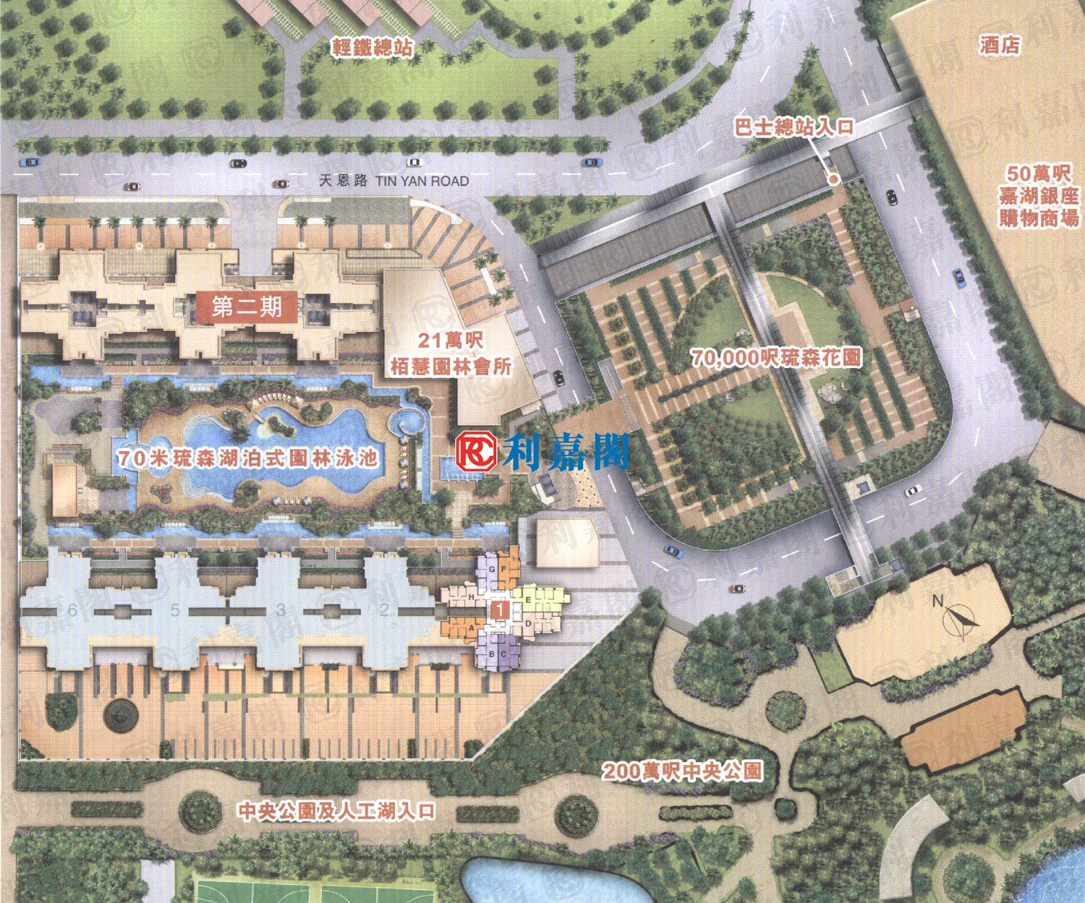
The squarish park is actually on the roof of the bus terminus.
X
LRT / Tram stops
← road →
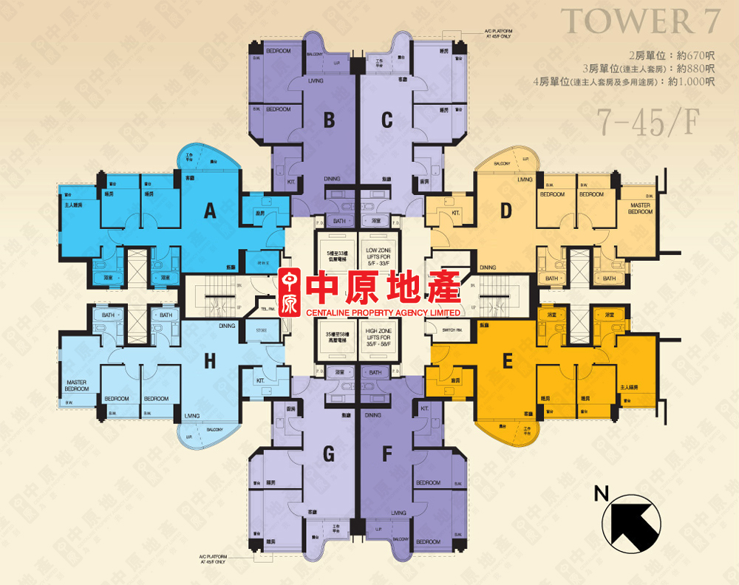

Actually, the flat is in Tower 9, but the layout is exactly the same. (If you count the number of towers there are only 8 - because of Chinese superstition, the number '4' meaning 'die' is omitted.)

